

maven

The

story

*Mentoring is a great tool used to shape and guide the youth to on their journey to become responsible and productive members of the community*



The challenges and opportunities of the digital age have left a great many teens in Africa lost as they attempt to find a path to follow...



## ....with these challenges the teens are on a free fall having limited role models at the local level, no formal way for them to pick up values that build true character and little or no pride in the African social culture.



**The Maven’s soul purpose** is to provide a platform for teens from all walks of life to identify the promise within each and every one of them, and an opportunity to rise up to be mavens, to champion a seamless cycle of every improving Excellence Continuity.



# We seek to understand and provide the African teen with a solid foundation for a productive life ahead....

Our mavens work to realign teen mentoring system in Africa by falling back to the collective communal way to collaboratively set up the youth to a fruitful future.

# To Positively Impact Africa by empowering the teen mindset.



MAVEN is a pragmatic mentoring instrument designed to equip the care giver and the African teen (14-17 years) with self-belief, values and an opportunity to live life to the fullest now.

**Our Promise; Excellence Continuity**



is

Our Philosophy

We impart self belief, positive values, soft skills and personal imprinting to build self aware and confident MAVENS in whose hands the fate of Africa and her future assured by continuity of excellence.

The MAVEN philosophy sits on three main pillars:

We train the teen to believe in themselves to build their Self Esteem; We teach through knowledge by exposure and job shadowing; Testing and learning by doing.

The ID

Logo Rationale:

**Iconography;**

The mirrored head represents the ideal mirroring of ideals and principals from Maven to student.

Represents growth from low carat gold ore to pure gold.

Represents continuity.

**Logo Type;**

Burnt orcher to represent Africa and her people. Simple solid font for the minimalist character.

**Excellence Continuity**

**Excellence Continuity**

The Brand Architecture

**APPRENTICE**

**EXCELLENCE CONTINUITY**

**EXCELLENCE CONTINUITY**

**MASTER**

**EXCELLENCE CONTINUITY**

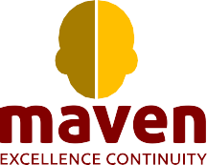

Stepehen Wandera

Director

The Other Building, Ground Floor, Chapa Avenue,

Nairobi, Kenya. P.O. Box 123434 - 00100, Nairobi Tel: +254 700 111002 | Email: [karibu@maven.com](mailto:karibu@maven.com)

+254 722 527 875

[wandera@maven.com](mailto:wandera@maven.com)

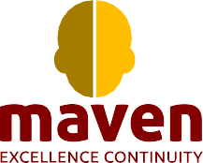

*With Complements*

The Other Building, Ground Floor, Chapa Avenue, Nairobi, Kenya. P.O. Box 123434 - 00100, Nairobi | Tel: +254 700 111002 | Email: [karibu@maven.com](mailto:karibu@maven.com)

Stationery

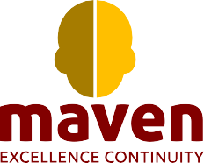

The Other Building, Ground Floor, Chapa Avenue, Nairobi, Kenya. P.O. Box 123434 - 00100, Nairobi | Tel: +254 700 111002 | Email: [karibu@maven.com](mailto:karibu@maven.com)

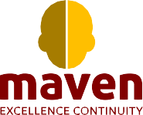

Stepehen Wandera

Director

+254 722 527 875

[wandera@maven.com](mailto:wandera@maven.com)



The Other Building, Ground Floor, Chapa Avenue, Nairobi, Kenya. P.O. Box 123434 - 00100, Nairobi Tel: +254 700 111002 | Email: [karibu@maven.com](mailto:karibu@maven.com)

[www.maven.com](http://www.maven.com/)